Ray Foulk
In 1969, the organisers of the legendary Woodstock Festival wanted to hold the event in or near the town of Woodstock, in upstate New York, because it was the home of the singer-songwriter Bob Dylan. They did everything they could to encourage Dylan to appear including keeping the name Woodstock even though the festival eventually took place 70 miles away in Bethel Woods. So who was the man responsible for disappointing them by luring Bob to an island few people in the USA had even heard of: The Isle of Wight? Step up Jericho resident, Ray Foulk. Ray, with help from his daughter, Caroline, has just written a book about that achievement which if it was in a novel would look unbelievable. Ray has called his book ‘Stealing Dylan from Woodstock’.
Ray’s older brother, Ronnie came up with the idea of mounting a music festival on the island and Ray joined him. They formed a company, Fiery Creations. Their other brother Bill also helped and together they organised the first festival in 1968. This was followed by the Dylan Festival in 1969. The 23 year old Ray was not long out of a five-year apprenticeship at the Isle of Wight’s newspaper when his life was turned upside down by the success of the event.
After a motor cycle accident in 1966 Bob Dylan withdrew from public performance. The Foulk brothers knew that if they could persuade him to appear at the 1969 festival, the eyes of the world would be on the Isle of Wight. The task of carrying out their plan was allocated to Ray. He said, “At the time I was fearless, and still I sometimes have a tendency to overreach, but we were in luck. It was surreal to hear his manager say, down the phone, that Dylan wanted to meet me in New York next week.”
Of course it wasn’t quite as simple as that. To get as far as that phone call, Ray had to persuade Bob’s manager that the brothers could raise (today’s equivalent) £¾ million: a staggering amount of money for the young promoters. Ray headed off to New York to meet the great man. “All the money and power couldn’t get him and lots had tried. I think we succeeded because we were young and amateur.”
Bob boarded the QE2 for England on the day the Woodstock Festival opened. Once it was known that Dylan would perform, “Everyone wanted to be there. The Beatles apart from Paul McCartney − who was about to become a father − landed in a helicopter on the lawn of the house. The Rolling Stones except Mick Jagger (who was in Australia) Yoko Ono, Elton John, Jane Fonda, Eric Clapton and a long list of Rock n Roll royalty gathered to see Bob perform. It was a global event,” said Ray.
The following year the line-up of over fifty performers included Jimi Hendrix, Joan Baez, The Doors, Miles Davis, The Who, Joni Mitchel and Leonard Cohen. The sensation created by this gargantuan feat was its undoing! Dismayed by the extraordinary attendance levels of 600,000 people, parliament passed the ‘Isle of Wight Act’, preventing gatherings of more than 5,000 people on the island.
After the festivals Ray and Ronnie headed for London. “We organised the first rock concert at Wembley Arena with Led Zeppelin (1971) and even got Prince Charles’ permission to feature The Who at The Oval that year (in aid of famine relief in Bangladesh). The following year we staged the first rock event at Wembley Stadium, with Chuck Berry, Bill Haley, Little Richard and Jerry Lee Lewis.”
Ray was headhunted by Milton Keynes to develop the leisure content of the new city. To assist with the megastuctures needed he brought in the American visionary, Buckminister Fuller whose ideas later had a profound effect on Ray.
“My life at that time looked glamorous enough: the Bentley, high-powered lunches, living in Mayfair but it was a product of a hectic life style.
“I sought a less hectic life and, in 1977, with my partner Jenny Lewis, we took a large building, in the Fulham Road, and converted it into a gallery over five floors. I’d been a collector since my teens and by then had developed a passion for Art Deco.”
Ray was being avant-garde because in 1977 even Victoriana was looked down upon by younger antiques dealers.
“We were lucky. Had we started later we couldn’t have raised the money needed to purchase the things we did. We began to buy furniture and objects by the top French designers, such as Emile-Jacques Ruhlmann and Süe et Mare and presented notable exhibitions of their work. Even then, we needed the equivalent of a small mortgage to buy their best pieces, but a few years later it would have been completely prohibitive.”
The V&A bought some seven items of furniture and objects from Ray for their twentieth century collection. This was not Ray’s final career. In the eighties, he won a place at Christ’s College and trained as an architect at Cambridge University.
“Once qualified, I set up my own design & build practice. Taking on Buckminister Fuller’s ideas, his science, philosophy and technological and environmental solutions, I established with my daughter, Caroline, The Millennium Debate NGO. In 1998 and we organised Oxfordshire’s ‘Blue Planet Days’, based on Fuller’s ‘Operating Manual for Spaceship Earth’: about valuing and not wasting natural resources.”
They organised nearly one hundred exciting all-day events in schools across Oxfordshire. Caroline wrote the multi-media play, Destination Spaceship Earth. Later, students presented their work in ‘Environmental Showtime’. In all, they worked with some 20,000 children over six years.
In 2010, when I interviewed Ray for Oxfordshire Limited Edition, he explained that there were so many embellished myths about the Isle of Wight Festivals that he ought to write about what actually happened. He was galvanised into action when an unexpected visitor arrived soon after I had left. Ray said,
“Our staff photographer, a close family friend called Peter Bull got a job in Australia after the 1970 festival. Forty years later he arrived on our shores saying that he had found reels of undeveloped film. He made them available to us.”
Stephen Goldblatt, better known as the director of photography on Batman, and many other Hollywood feature films, was a fellow student of Ray’s brother at the Royal College of Art and was given exclusive back stage rights. “We tracked him down in LA and he gave us access to his pictures too.” said Ray.
The result is that of the 150 pictures in Stealing Dylan from Woodstock, 100 have never been seen in public before. Ray and Caroline’s book will be released on May 22. The full story of Ray’s coup and the amazing pictures should make it a must have read for anyone interested in the sixties.
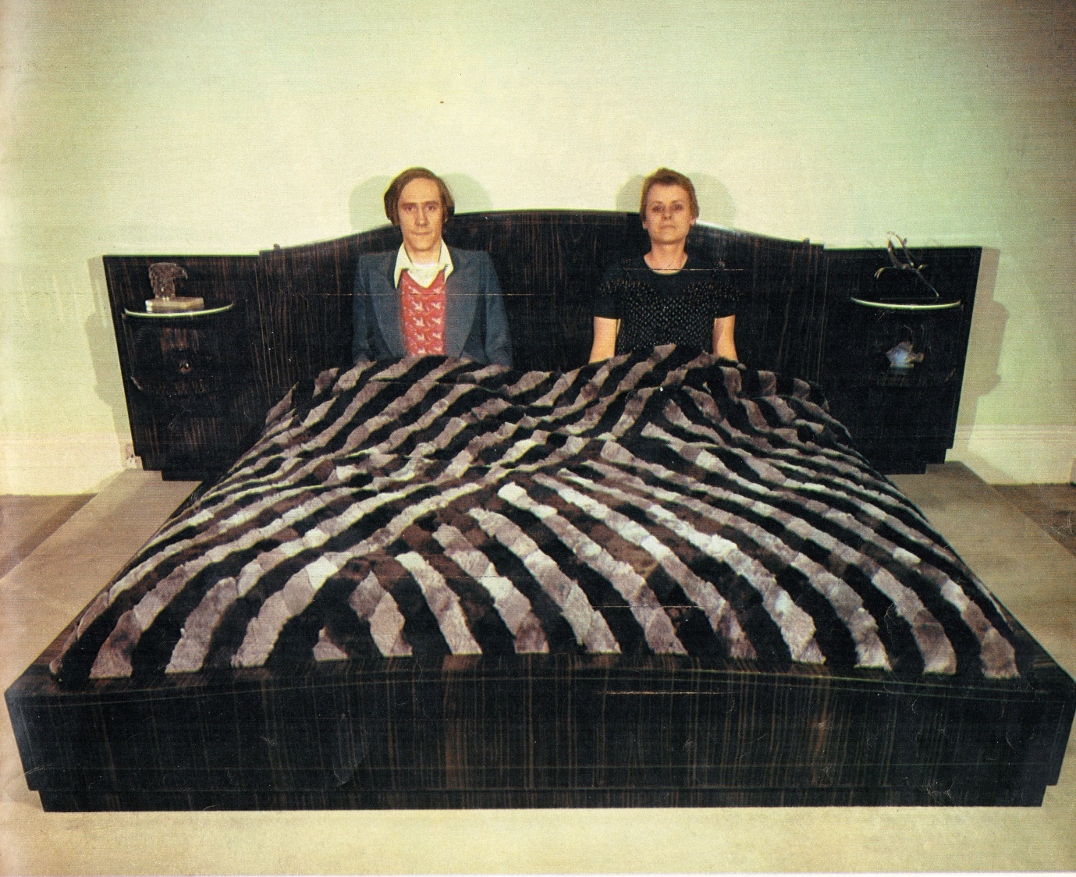
Ray Foulk and Jenny Lewis showing off their macassar ebony bed by Emile Jacques Ruhlmann (1879-1933), Fulham Road London, 1978.
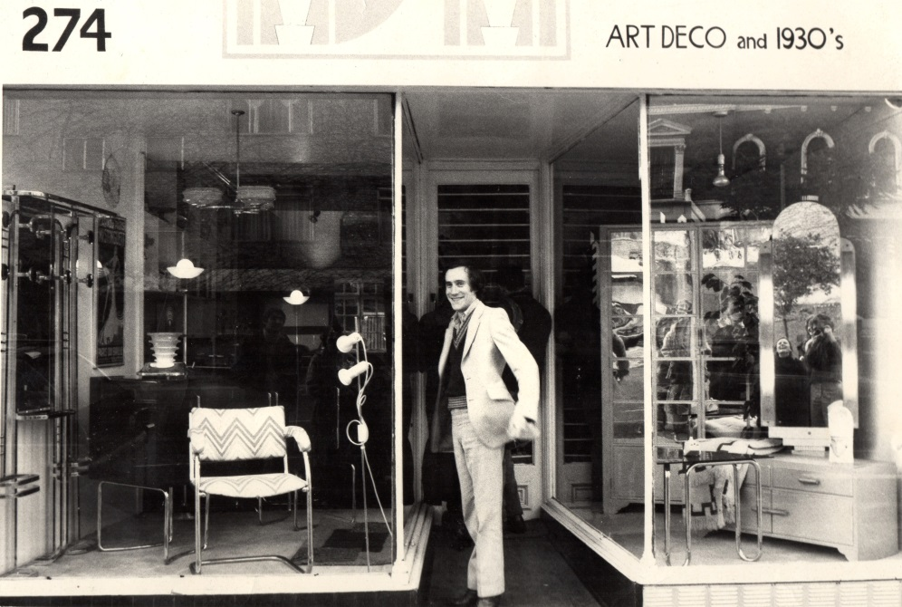
Ray Foulk outside his Art Deco gallery, Fulham Road, 1978
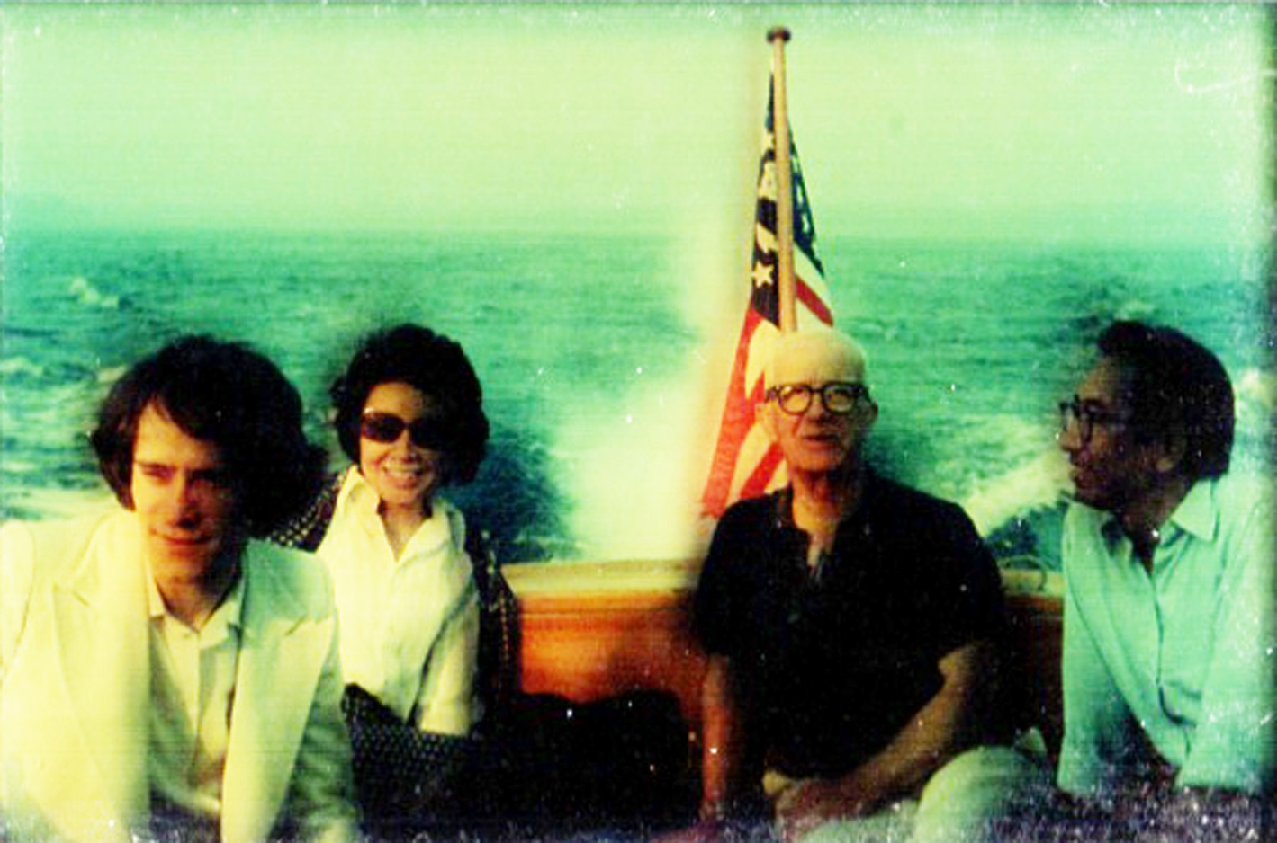
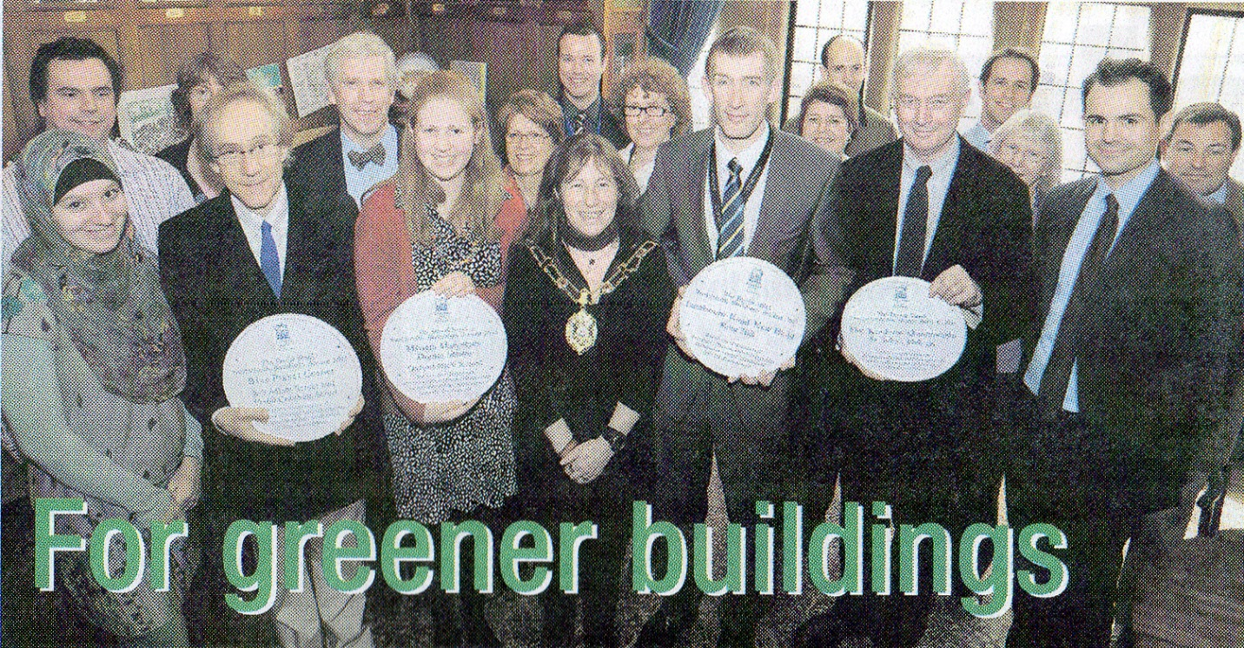
This is one of the best. Ignore the poor quality. I have this as a 35mm colour transparency and it will reproduce 20 times better than this. In the picture L to R: Ray, Shoji Sadoe’s wife. R Buckminster Fuller, Shoji Sadoe (Fuller’s architectural partner). 1974.
Extract from Oxford City Council newspaper, Summer 2012. ‘David Steel Sustainable Buildings Award’, 2011. Left to Right: Cordelia Foulk, Paul Foulk, Eloise Benjamin (Lord Mayor) in centre.

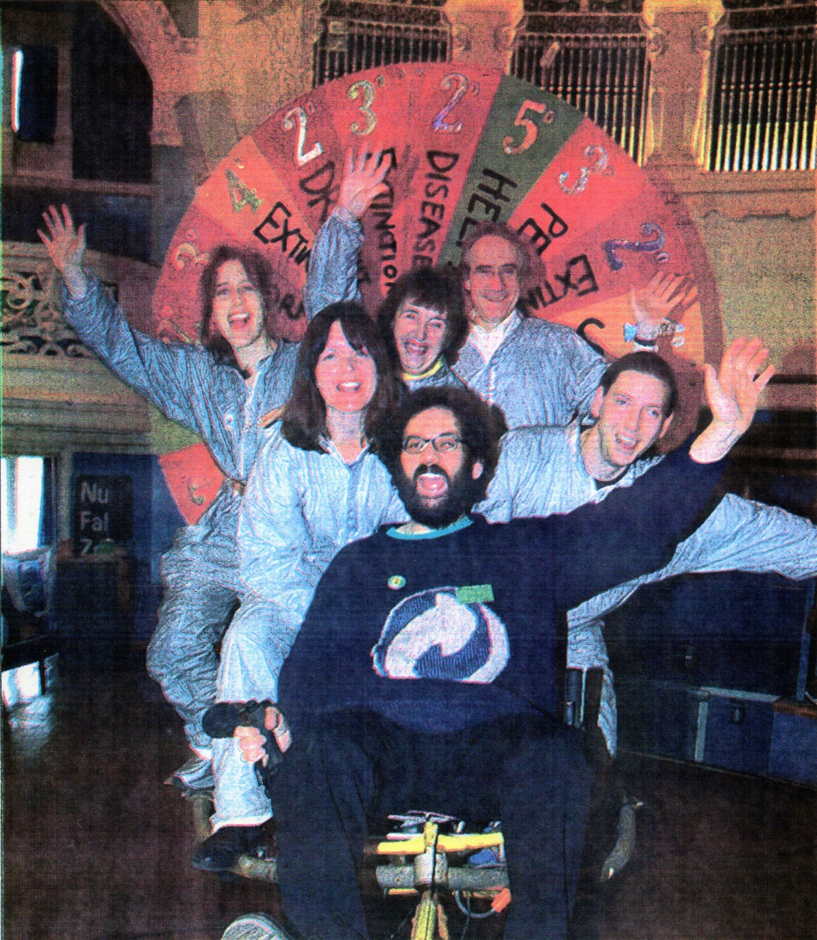
Ray Foulk and Blue Planet Day team with Green Councillor Craig Simmons, at the Oxford Green Fair, December 2002. Left to right: Caroline Foulk, Sarah Brown, Audrey Tomkins, Dr Chris Jatrdine. Craig Simmons, front centre.
From Oxford Mail, 17 December, 2002

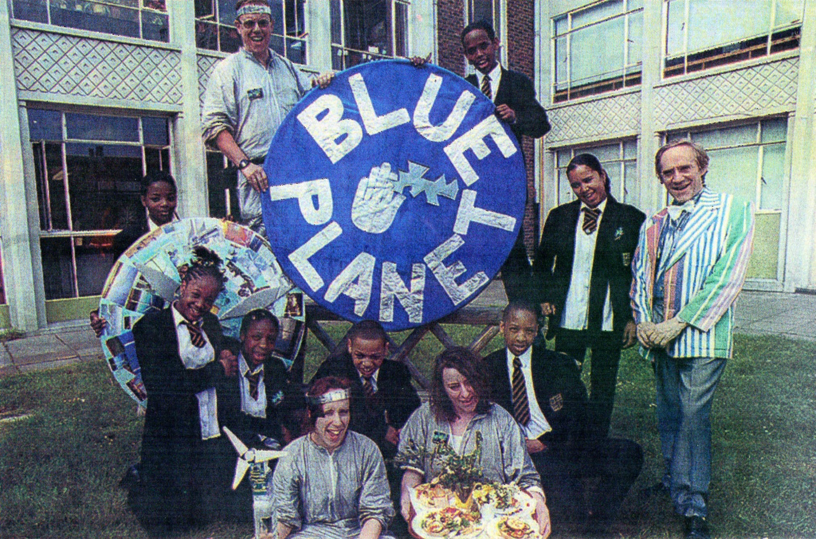
Ray Foulk (left) this Blue Planet Day team members and students. Archbishop Michael Ramsey School, Brixton. Top, Tim Jones. Bottom centre, Caroline Foulk and Claire Palmer.

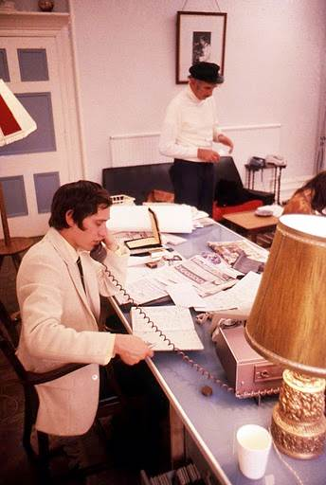
Ray Foulk at his office desk, 1970, with Bert Block (Bob Dylan’s manager)

