Join Friends of Kennington Library to celebrate our new look library on Saturday7th March 2015!
Mezzopiano
Rebecca MARTIN and Nia Williams
Will perform
Smoke and Mirrors
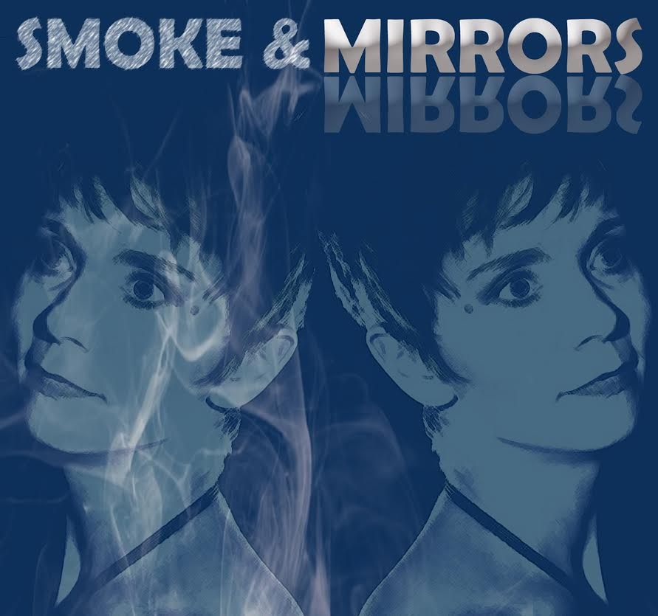
at
Kennington Village Centre
Drinks available from 6:30pm. Library open from 6:45pm
Show starts at 7:30pm
Followed by bring-and-share finger buffet and bar
Tickets £12.
Tickets and buffet donations list available from:
Helen Forey at the box office: Telephone: 01865 739004, Mobile: 07810 720225
Email: helen.forey@btinternet.com
Sylvia Vetta Email: sylviavetta@gmail.com
or from the library during opening hours.

