Contact: Laura Brudenell White
laura@cameronpm.co.uk
07595 938413
PUBLISHING 3rd March
AUTHOR AVAILABLE FOR INTERVIEW

Brushstrokes in TIme
By Sylvia Vetta
‘In politics we want democracy and in art we want freedom.’ The Stars

- A stunning eye opening fictional tale set in China from 1963-1993; Wild Swans meets Dr.Zhivago.

- A story of love and hope told against a background of real events.

- Set amongst characters from The Stars – a radical movement of artists, including Ai Weiwei, whose 1979 exhibition changed art forever in China.

- “A deeply informed portrayal of the little-known, important Stars Art Movement.” Maria Jaschok, Oxford University

- The haunting story of fictional artist, Little Winter, connects us to this time of hope for freedom of expression in China and to a man frustrated by being kept ‘in small shoes’.

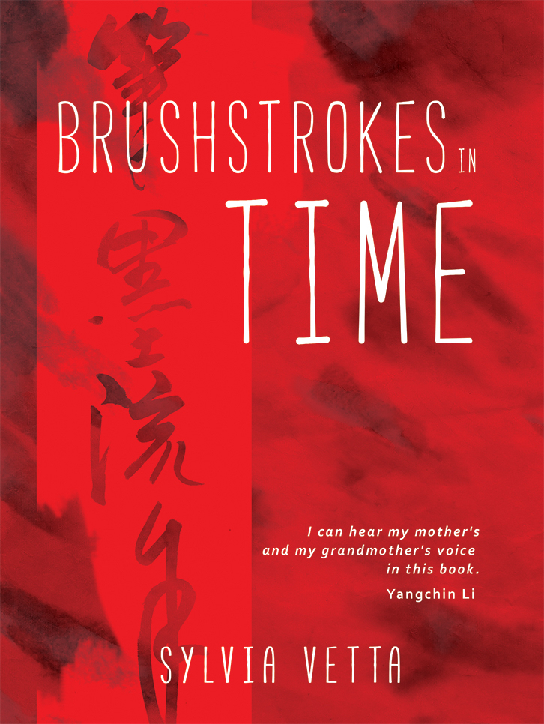

Weaving real events and the creative minds that called themselves The Stars, Brushstrokes in Time, is a revealing debut novel by Sylvia Vetta.

In Brushstrokes in Time, Vetta takes the reader back to 1963, when Chairman Mao was still presiding over China but takes us beyond the death of Mao and for the first time in fiction shows the birth of the radical art movement, The Stars, in 1979. At the heart of this book is the period which saw the creation of the China we know today. The reader does not need to know anything about China to access this book and find the story of Little Winter (Xiaodong ) a compelling read. Walk in Little Winter’s shoes and at the end of that emotional journey the reader will have learned a great deal about that complex culture and country.
“This is the book I struggled not to write. I buried the pain along with my Chinese name and changed my fate. But your father believes you will only understand yourself as well as me if you know my story, my journey from my childhood home on Beijing’s Millionaire’s Avenue to the only home you know on College Avenue, Berkeley, California.”
At the centre of the novel is the story of Winnie – previously known as Little Winter, a mother describing her life story to her American daughter, pivoting between the past and present, introducing her daughter to loves passed and tragedies experienced - expressing emotions that have not only shaped her life but also in a way, her daughter’s.
Live their lives, find yourself consumed by their hopes, successes and fears and cherish a love story as it unfurls.
“It is a very beautiful story, well told and in a very appropriate and enchanting voice.”
Michael Smith, author of Station X.
To access an article on the background of the book, please visit: http://www.sylviavetta.co.uk and to download the article, please click here.
About the Author

Freelance writer, journalist and speaker Sylvia Vetta worked in antiques for many years before
taking up freelance writing and broadcasting on art and antiques in 1998, when she began writing features for the award winning magazine of The Oxford Times, ‘Oxfordshire Limited Edition’. She created Oxford Castaways sending over 100 inspirational people to the mythical island of Oxtopia. As a result she has interviewed among others, Sharmi Chakrabarti, Sir Roger and Lady Moyra Bannister, Lord Patten of Barnes the last governor of Hong Kong, prolific writer Brian Aldiss, folk legend Peggy Seeger, Nobel Peace Prize winner (with MAG) the sculptor John Buckley, Sister Frances Domenica, the founder of the world’s first children’s hospice, physicist Christopher Watson, who helped dismantle 220 rotting Soviet nuclear submarines, Lady Carnarvon, the mistress of the real Downton Abbey. Reviewing Everyone’s Life is an Epic , the first one man show by a living Chinese artist to be held at the Ashmolean , she learned first -hand from one of the founding Stars the story of their courage and their dreams. That encounter with Qu Leilei and the epic story he told, inspired her to write this novel.
She lives near Oxford with her husband.

Notes to Editors:

- Following the Oxford Launch in Blackwell’s of Brushstrokes in Time the London launch will be at Polka Theatre, in Wimbledon, where Stars artist Qu Leilei now lives : Thursday March 3 at 7.15pm.
- Sylvia Vetta has extensively researched The Stars movement and this period of Chinese history. She has had in depth interviews most significantly with Qu Leilei .
- Ai Weiwei has recently exhibited at the Royal Academy in London and has a touring exhibition currently being shown in Melbourne. His “Selfie Wall” is on display at Bonmarche, Paris until 20th February.
- Qu Leilei and many of the other Stars have been extensively collected across the world. Lesser known than his contemporary, Ai Weiwei, Qu Leilei’s work is collected/exhibited by the V&A, the Ashmolean, the Japan Modern Art Museum, The China National Art Museum and The British Museum.
Brushstrokes in Time is available at all good bookshops and online booksellers.
Published by Claret Press £7.99 Paperback Original

