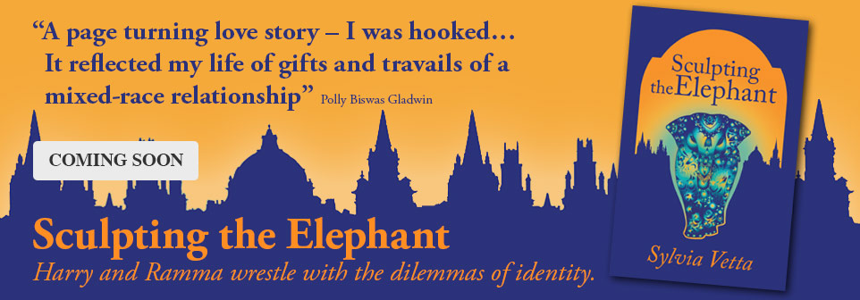
The Launch of Sculpting the Elephant at Antiques on High
Sylvia Vetta’s second novel Sculpting the Elephant is inspired by her own life experiences in a mixed marriage and in a twenty year career in the art and antiques trade. You are invited to explore the ideas behind Harry King’s shop Deco-rators with the author Sylvia Vetta and with Caroline Henney - vintage jewellery expert at Antiques on High and one of the inspirations for the character of Kathy in Sylvia’s novel.
Thursday May 2 @ 4.30pm : Sylvia will be in Antiques on High for sales and signings. There will be the opportunity to take part in a fun antiques hunt quiz and a Deco prize will be awarded to the winning entry. (In the case of more than one –there will be a draw. )
At 5 pm there will be a short video about Sculpting the Elephant and some archive material from the world of art and antiques in Oxford will be on display. Caroline and Sylvia will talk about the book and guide visitors around Antiques on High pointing out relevant twenties and thirties objects fashion and jewellery. For those who would like to continue conversation with Sylvia, Caroline and other interesting guests they will cross the road to St Mary’s and everyone is welcome to join them for
TEA @ the VAULTS approx 5.30.
Monday May 13: Sylvia will be in Antiques on High for conversation, reminiscence and book signings from 3.30- 5pm
Saturday June 1: The finale of the May Sculpting the Elephant theme in Antiques on High Sylvia will be present from 2.30-4.30 pm. She will give away copies of features she wrote on Deco and we will raise a glass at the end!

S

